**Team ID :** PNT2022TMID37482

IBM ID :- [**IBM-Project-49882-1660882154**](https://github.com/IBM-EPBL/IBM-Project-31900-1660206003)

int buzz=4; int pir=7; int echo=5; int trigg=6;

int pir_led=12; int us_led=13; int time ;

int dist; void setup()

{

Serial.begin(9600); pinMode(pir_led, OUTPUT); pinMode(us_led, OUTPUT); pinMode(buzz, OUTPUT); pinMode(pir, INPUT); pinMode(echo, INPUT); pinMode(trigg, OUTPUT);

}

void loop()

{

if (digitalRead(pir)==HIGH){ Serial.println("There is a person..."); digitalWrite(pir_led,HIGH); delay(1000);

}

digitalWrite(pir_led,LOW); digitalWrite(trigg,HIGH); delayMicroseconds(10); digitalWrite(trigg,LOW);

time=pulseIn(echo,HIGH); dist= (time*0.034)/2;

if (dist<=50)

{

Serial.println("A person Near..."); digitalWrite(us_led,HIGH); analogWrite(buzz,HIGH); delay(1000);

}

else

{

digitalWrite(us_led,LOW); analogWrite(buzz,LOW); delay(1000);

}

}

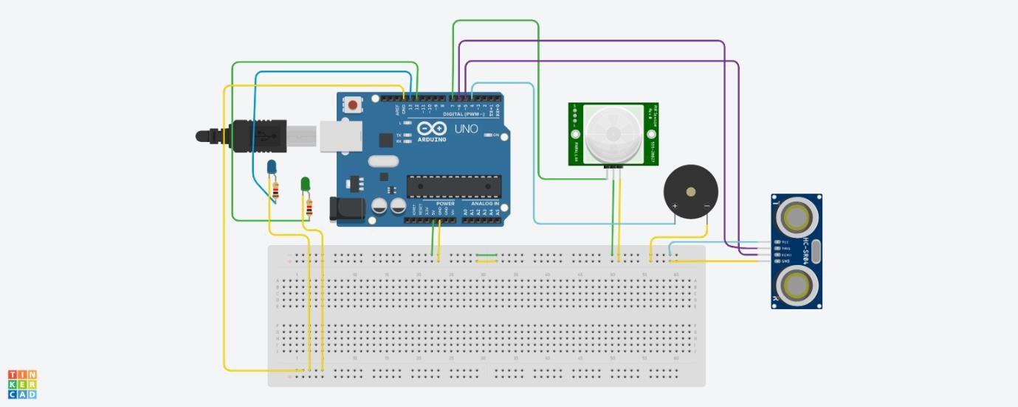

https://[www.tinkercad.com/things/9isSjSIVRG6-glorious-kasi/editel?sharecode=vni04c-](http://www.tinkercad.com/things/9isSjSIVRG6-glorious-kasi/editel?sharecode=vni04c-) U5jZdcG7G2uKm9pSedL-lLUhw-JwfhX9orzI